Steps to Create a Facebook Event

Sign On to Facebook and Click on the “Home” tab on the top bar.
Next click on “Events” on the left side of the screen under the Explore section.

The pull down menu will prompt you to choose to create a Private or Public Event. You will want to choose “Create Public Event.”

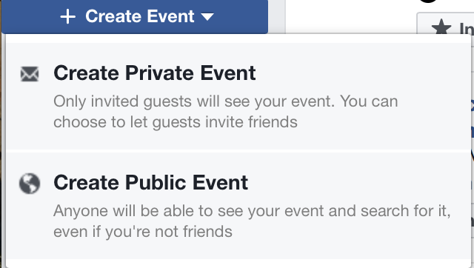

This will trigger the main event page, which will need to be filled in. Fields include; Event Host, Basic Info, Photo or Video, Event Name, Location, Dates and Time, Details, Keywords and Options.

ADG has sample information for the Basic Info. section and Description Section. The samples can be modified and easily cut and pasted into the designated areas.

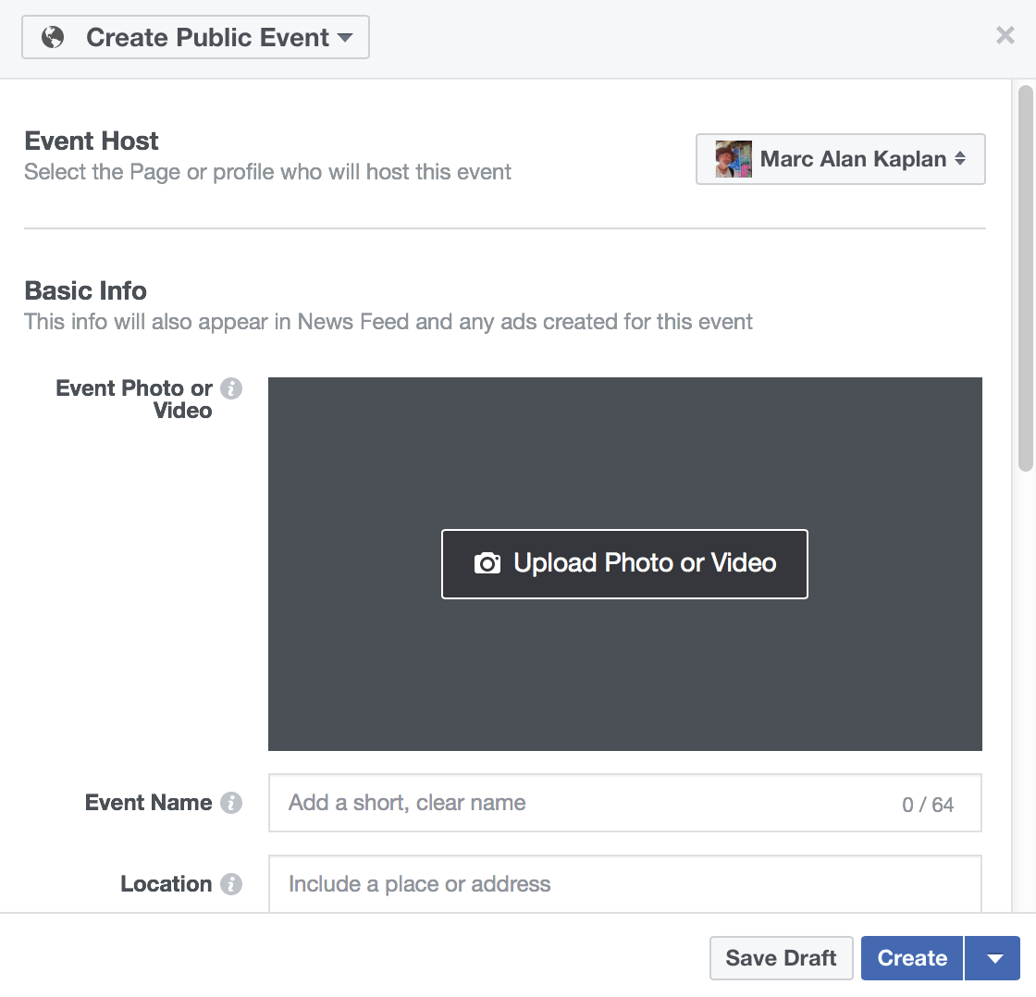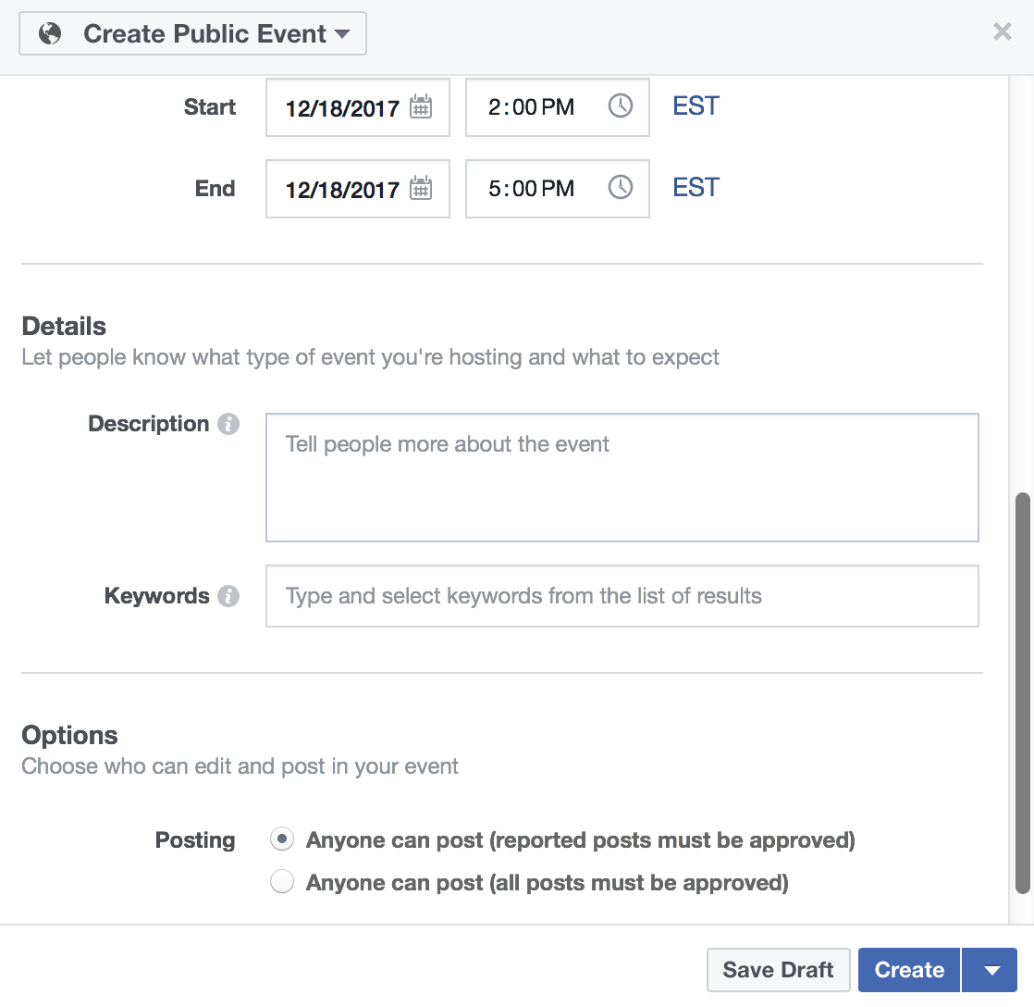

Amateur Disc Golf Sanctioned Disc Golf Tournament

Date: January 13, 2018
Time: 2:00pm
Location: Perkerson Park, Atlanta, GA (Pavilion by hole five’s tee pad)
Entry Fee: $15 (Registration fee includes a disc with a retail value of $9)

Schedule:
1:15pm Player online registration closes
1:20pm Putting Clinic
1:45pm Player’s meeting
2:00pm Start of Round
4:00pm Awards Ceremony

Notes:
This is an amateur only event. All awards will be paid out in a variety of quality disc golf merchandise, not cash.
It is a one round tournament consisting of 18 holes.
Prizes will be awarded to the top 50% in each division. The payout chart is available to all participants.

Divisions:
There are a total of six available divisions, three for women and three for men.
Players divisions consist of Novice, Intermediate and Advanced
- Novice – Players who are new to the game who are just learning basic throwing techniques.
- Intermediate – Players who have played in previous tournaments and have achieved a basic consistency and accuracy in their game.
- Advanced - Players who have played in a number of organized tournaments and are throwing over 200 foot drives and are consistent with their approach and putting skills.
The tournament event director will assist players to make sure they are in the correct division. Players will naturally move up in divisions as their skill levels increase.

Registration:
All participants must register online through the Amateur Disc Golf website www.amateurdiscgolf.org before the close of player registration. Players must register on or before the Sunday prior to a weekend event in order to receive their player’s package disc the day of the tournament. This is due to meeting shipping deadlines.

Prize Rewards:
All players who finished in the top 50% of the field in their division can claim their awards through DGU store.

